Preface
This system falls under the category of operational management regulations.
This system is proposed and drafted by the Department of Science and Technology Innovation.
This regulation shall be interpreted by the Department of Scientific and Technological Innovation.

Tooling Optimization Management Procedure
1 Scope
This document specifies the process verification and optimization of tooling, leading to the proposal of a tooling optimization plan, which further enhances production efficiency.
This document applies to the production of civil aircraft.
This document is formulated in accordance with the requirements of the GLG1407 Tooling Equipment Management Regulation.
2 Normative Reference Documents
none
3. Table
3.1 Defined Tables
none
3.2 Reference Tables
FM2605-29 Safety Hazard Rectification Notice
FM1407-78 Tooling Verification List
FM1404-04 Tooling Production Capacity Table
FM 1405-50 Process Equipment Variety Lis

4 Terms and Definitions
none
5. Institutions and Responsibilities
5.1 Science and Technology Innovation Department
The Science and Technology Innovation Department serves as the organizing and coordinating unit for tooling optimization. The Technical Office is responsible for evaluating and approving the tooling production capacity table, while the Science and Technology Innovation Department reviews and approves the tooling variety list and tooling application forms submitted by user units. It also approves the tooling optimization applications prepared by user units.
5.2 Tooling Usage Unit
Organize the trial use of work fixtures, document issues encountered during their use, maintain a verification checklist for work fixtures, compile a production capacity table for work fixtures, prepare a work fixture tool inventory list, and draft work fixture application forms;
6. Requirements
6.1 Compliance Management Requirements
none
6.2 Risk Management Requirements
no

6.3 Requirements for Tool Optimization Management
6.3.1
Based on the production capacity demand report, the user unit shall prepare a tooling calculation table, compile a tooling variety table according to the tooling production capacity table, prepare a tooling application form, and propose tooling requirements;
6.3.2
The tooling user shall optimize the tooling scheme based on the tooling safety hazard rectification notice, optimize the tooling structure and scheme, prepare the tooling application form, and submit the tooling application.
6.3.3
After the completion of tooling manufacturing, tooling testing shall be carried out according to the requirements, a tooling verification checklist shall be filled out, verification issues shall be recorded, and the tooling scheme shall be further optimized to improve the tooling structure and meet the requirements of safety, efficiency, and process optimization.
6.3.4 Prepare and improve the tooling variety list, tooling application form, and complete approval.
6.4 Department of Science and Technology Innovation
6.4.1 The technical office shall evaluate and approve the tooling calculation table of the user unit, and the approval process shall be combined with the production capacity analysis report, main stage schedule, manufacturing overall plan, etc. to evaluate the rationality of the tooling calculation table;
6.4.2 The Ministry of Science and Technology Innovation shall approve the tooling variety list and tooling application form proposed by the tooling user unit.
6.4.3 Evaluate and approve the tooling optimization application prepared by the tooling user unit, and complete the tooling manufacturing.

7 processes
7.1 Tool Optimization Process
7.1.1 Tooling Optimization Process Diagram

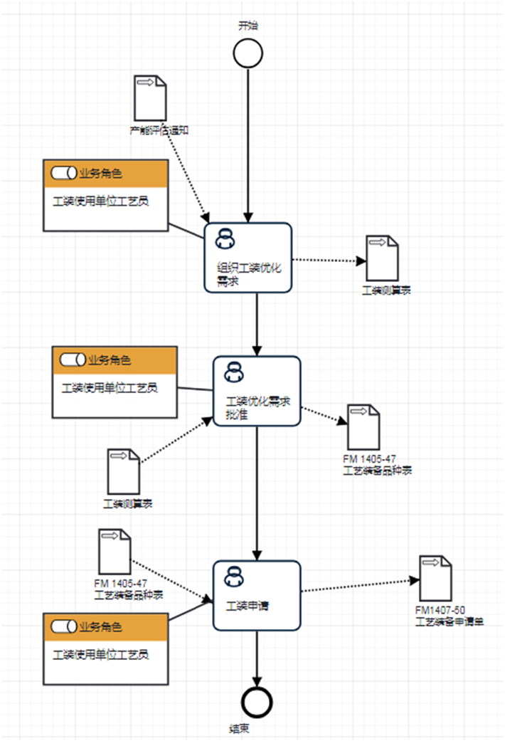
7.1.2 Tooling Optimization Process Description Table
(1) Prepare a table of tooling production capacity
Prepare a table of tooling production capacity | Step description | Based on the production capacity analysis report and tooling capacity, plan the required tooling for product implementation.
Prepare a table of tooling production capacity | activity frequency | 2 weeks
Prepare a table of tooling production capacity | Process Role | Technical personnel of the user unit | position | No
Prepare a table of tooling production capacity | Input material | Capacity Analysis Report | Output material | Table of Tooling Production Capacity
Prepare a table of tooling production capacity | Compliance terms | No
Prepare a table of tooling production capacity | Homework Execution Standards | No
Prepare a table of tooling production capacity | Risk and response measures | No

(2) Prepare a list of tooling varieties
Prepare a list of tooling varieties | Step description | Based on the tooling production capacity table, evaluate tooling requirements and prepare a tooling variety table.
Prepare a list of tooling varieties | activity frequency | 2 weeks
Prepare a list of tooling varieties | Process Role | Technical personnel of the user unit | position | No
Prepare a list of tooling varieties | Input material | Table of Tooling Production Capacity | Output material | List of Fixture Varieties
Prepare a list of tooling varieties | Compliance terms | No
Prepare a list of tooling varieties | Homework Execution Standards | No
Prepare a list of tooling varieties | Risk and response measures | No

(3) Prepare a process equipment application form
编制工装申请单 | Step description | Prepare a tooling application form based on the tooling production capacity table and tooling variety table.
编制工装申请单 | activity frequency | 2 weeks
编制工装申请单 | Process Role | Technical personnel of the user unit | position | No
编制工装申请单 | Input material | List of Fixture Varieties | Output material | Tooling Application Form
编制工装申请单 | Compliance terms | No
编制工装申请单 | Homework Execution Standards | No
编制工装申请单 | Risk and response measures | No

8 Process Role Responsibility Table
role name | responsibility
Technician in the Process Equipment Room | Approval of tooling application form
Technical personnel of the user unit | Prepare a table of tooling production capacity
Deputy Chief Craftsman of the Technical Office | Deputy Chief Craftsman of the Technical Office

9 Process Performance Indicator Table
none
Establish the following management standards to support this program
none
11 Record Control
none

